**Checking Attendance System**

**Guidelines**

*Group members:*

*1451018 - Tô Bạch Tùng Hiệp*

*1451031 - Đàm Tuấn Khôi*

*1451032 - Bùi Nhật Khôi*

*1451050 - Lê Văn Tâm*

*1451061 - Cấn Cao Trí*

**I - Installation**

* First of all, make sure you have all the necessary tools required before you start installing this, which includes: node.js (latest version - can be found in <https://nodejs.org/en/>), a web browser (Chrome, Firefox,...)
* Then, to install the application, go to the folder where the source code is and open cmd (or open cmd and move to that folder). Then type in “npm install”. Wait for the process to run until you reach this screen.

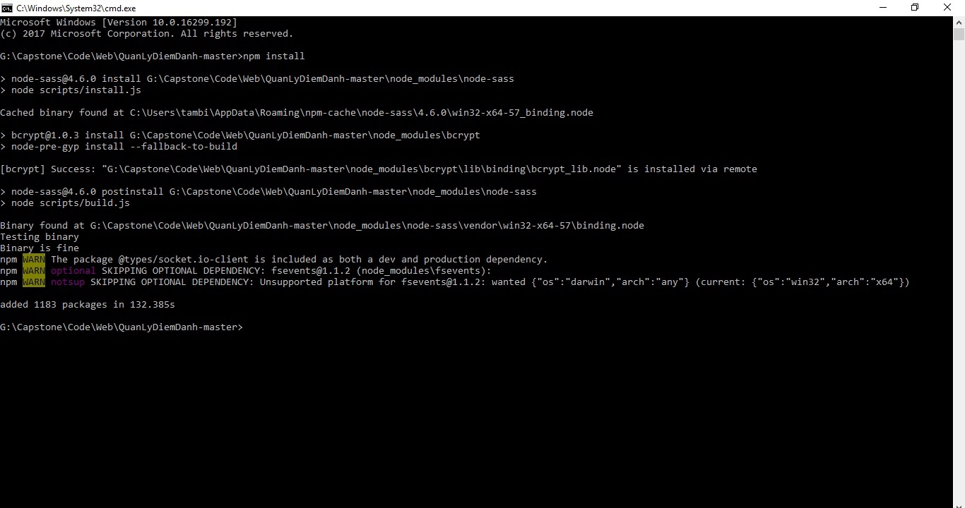

* That means the website is installed. After this, type in “npm start” to begin the node application. Wait for the process to run until you reach this screen:

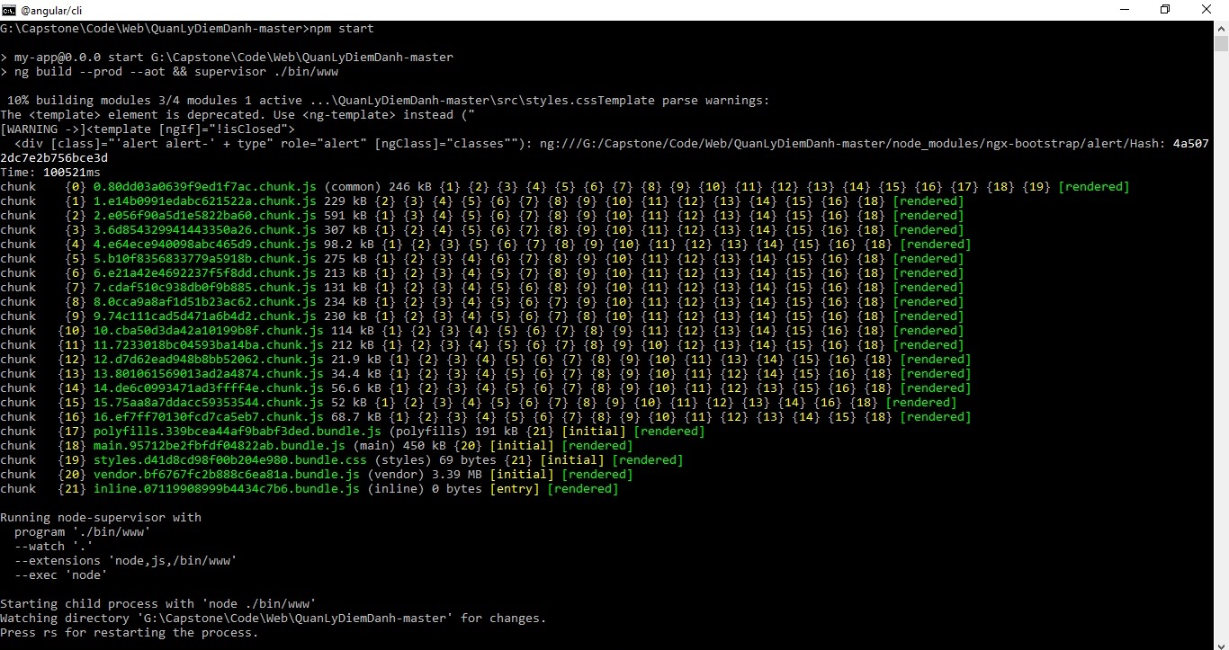

* In the newer version (source code in latest folder), after this, you must run “ng build --aot” instead to start the web page. The process is similar to the “npm start”, you just need to wait until it is finished.
* Then, go to your web browser and type in “<http://localhost:3000/login>” or “<http://localhost:4200/login>”to access the login interface of our web application. From there, you can log in with an accounts and perform actions based on the type of account. Please read the second section to know how to use correctly.

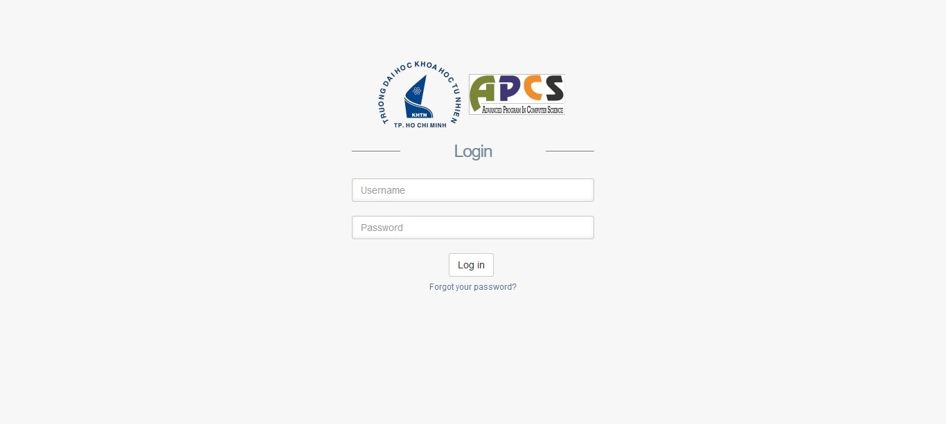

* For configuration, please…
* If you encounter any bug when installed, please try to reinstall all the necessary tools and start install the web application with “npm install” before follow the above steps again. And if the problem is still not resolved, please contact a member from one of our team for further guidance.

**II - How to use**

1. *For Student:*

* When you first enter, you will be greeted by this screen below, which is in ‘Dashboard’ tab. In here, you can click the ‘Edit’ button to change your personal information (includes your name and phone number) and re-login to see the changes. In this tab, you can also view currently opening courses and click the ‘Request to be checked’ button (if the course is opening) so the teacher can check you in their courses. You can also view your attendance progress by scrolling down a little.

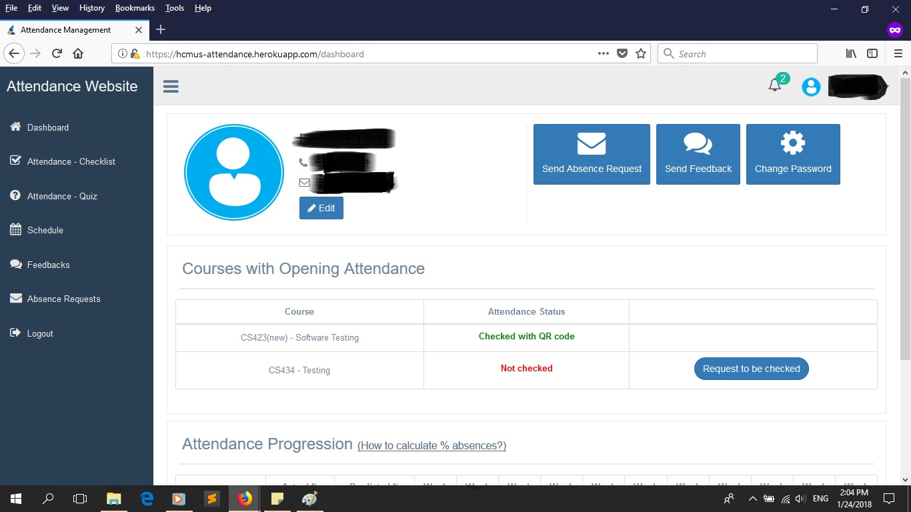

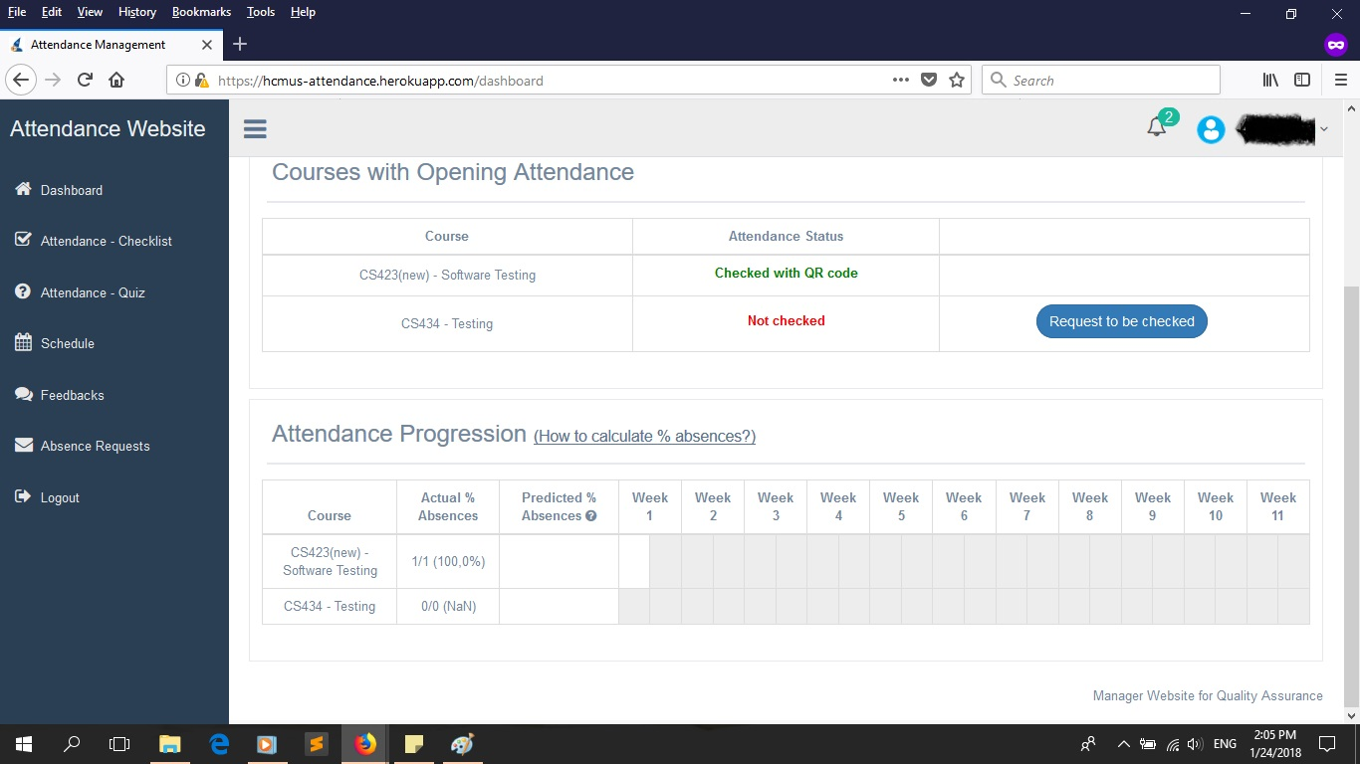

* + Click on the ‘Absence Request’ to send your request and choose the date you want to stay absence to the staffs.

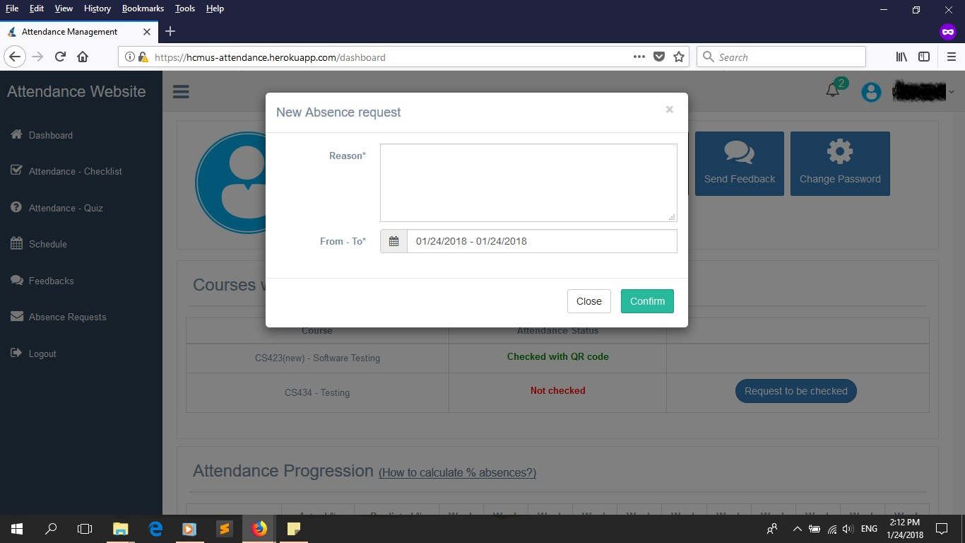

* + Click on ‘Send Feedback’ to send feedbacks to staffs. In the screen, please fill in all needed information before click ‘Send’. You can also tick ‘Anonymous’ if you don’t want the other side to know who sent this.

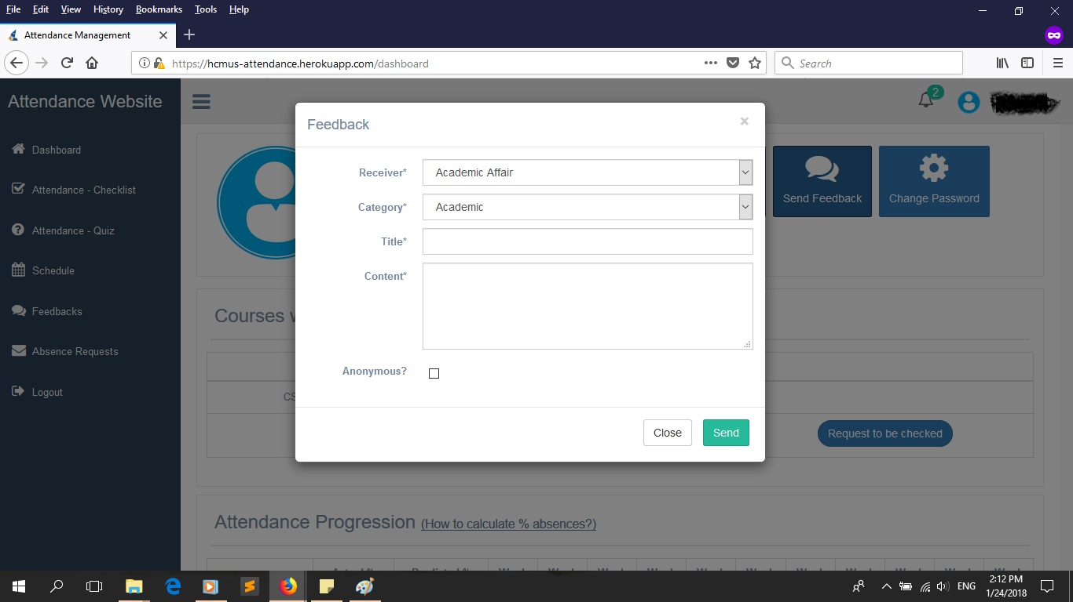

* + Click on ‘Change password’ to change your password.

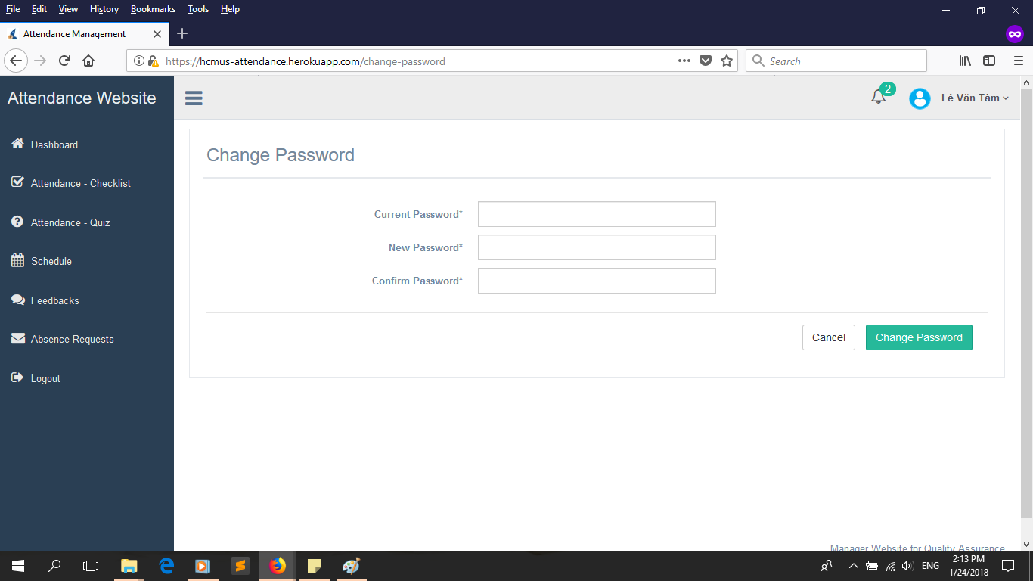

* Switch to ‘Attendance-Checklist’ tab and enter the code teacher gave you. This tab will allow you to view the list all students in class and you can check them in by clicking on their avatar.

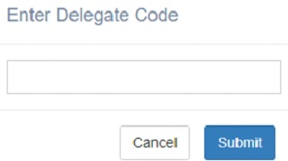

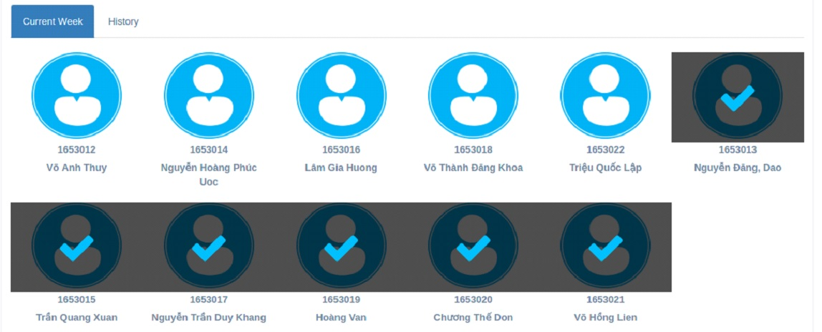

* Switch to ‘Attendance-Quiz’ tab and enter the code teacher presented. This tab will let you join a quiz test created by the teacher and by answering the questions given, you can check in. If the question type is ‘Academic’’ then not all answers needed to be correct, otherwise, all of them needed to be correct for you to check in. If you don’t any question question then you are automatically out.

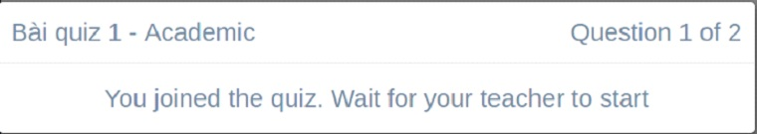

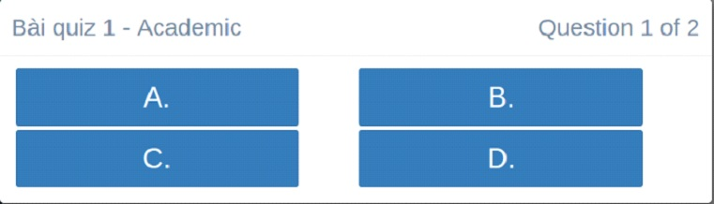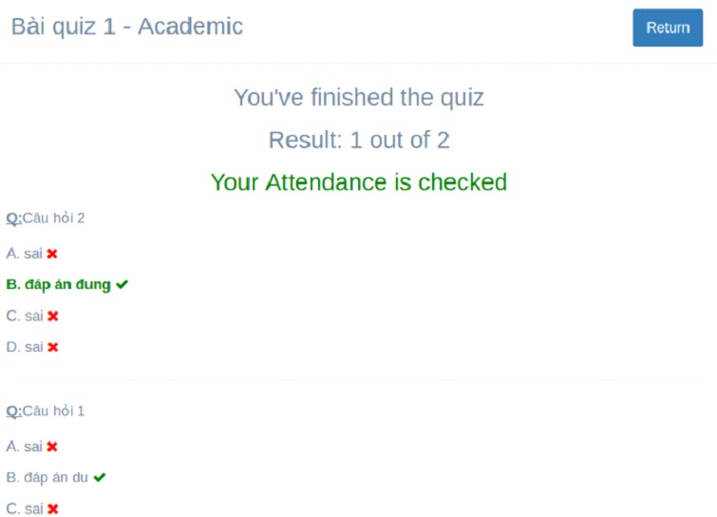

* Switch to ‘Schedule’ tab to view the schedule of your courses over the weeks. Click on the date to view more details.

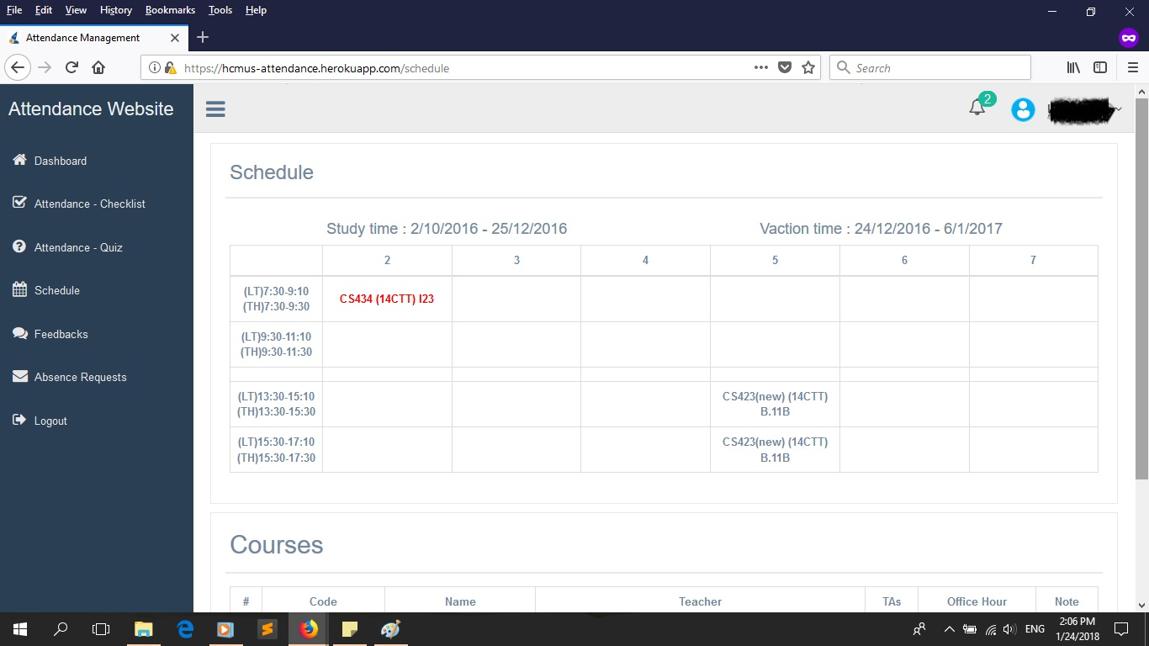

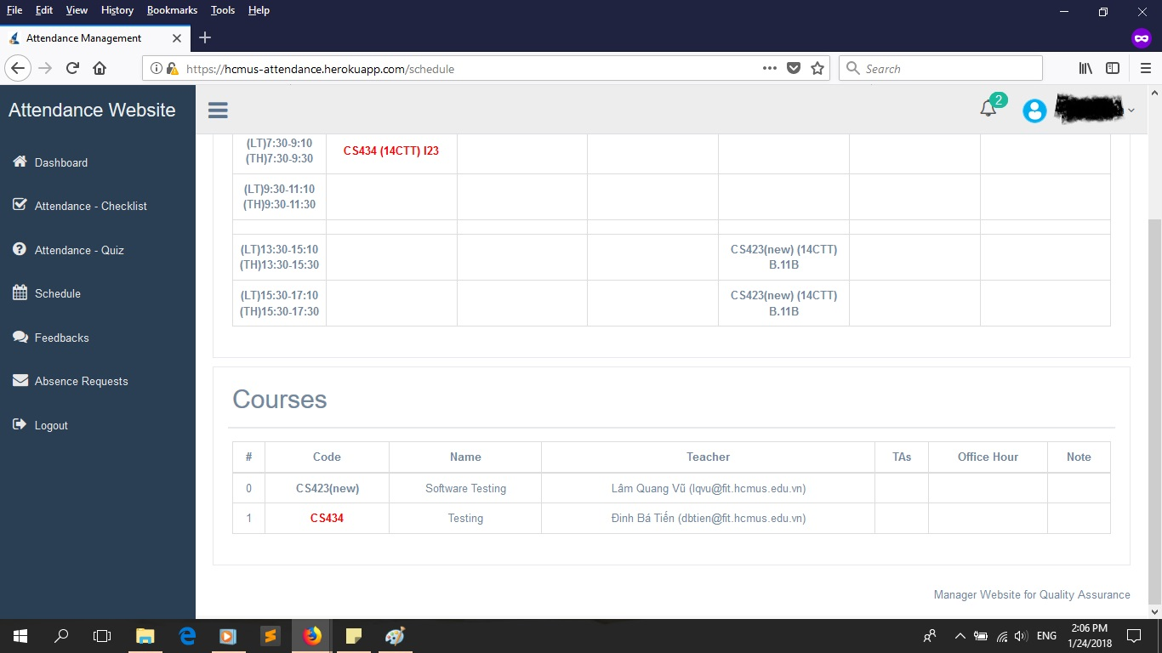

* Switch to ‘Feedbacks’ tab to view all your feedbacks and see if there were any reply yet.

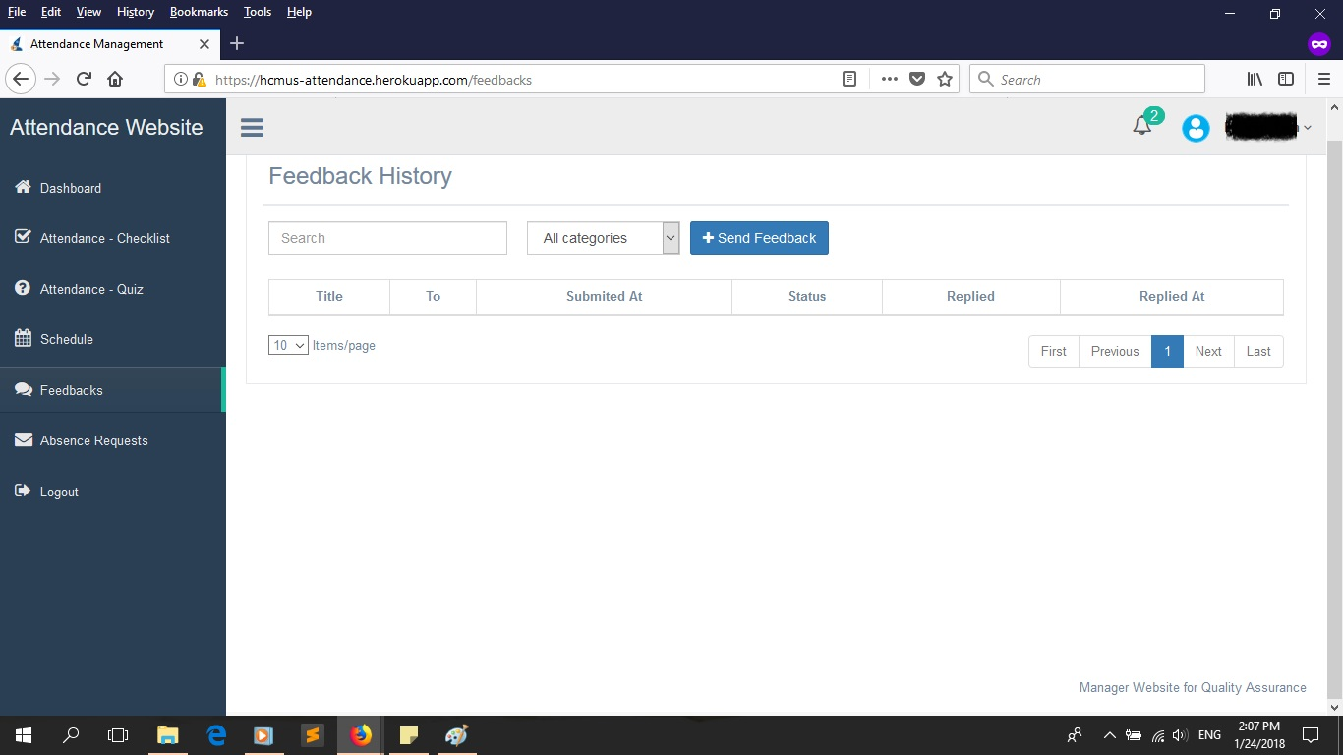

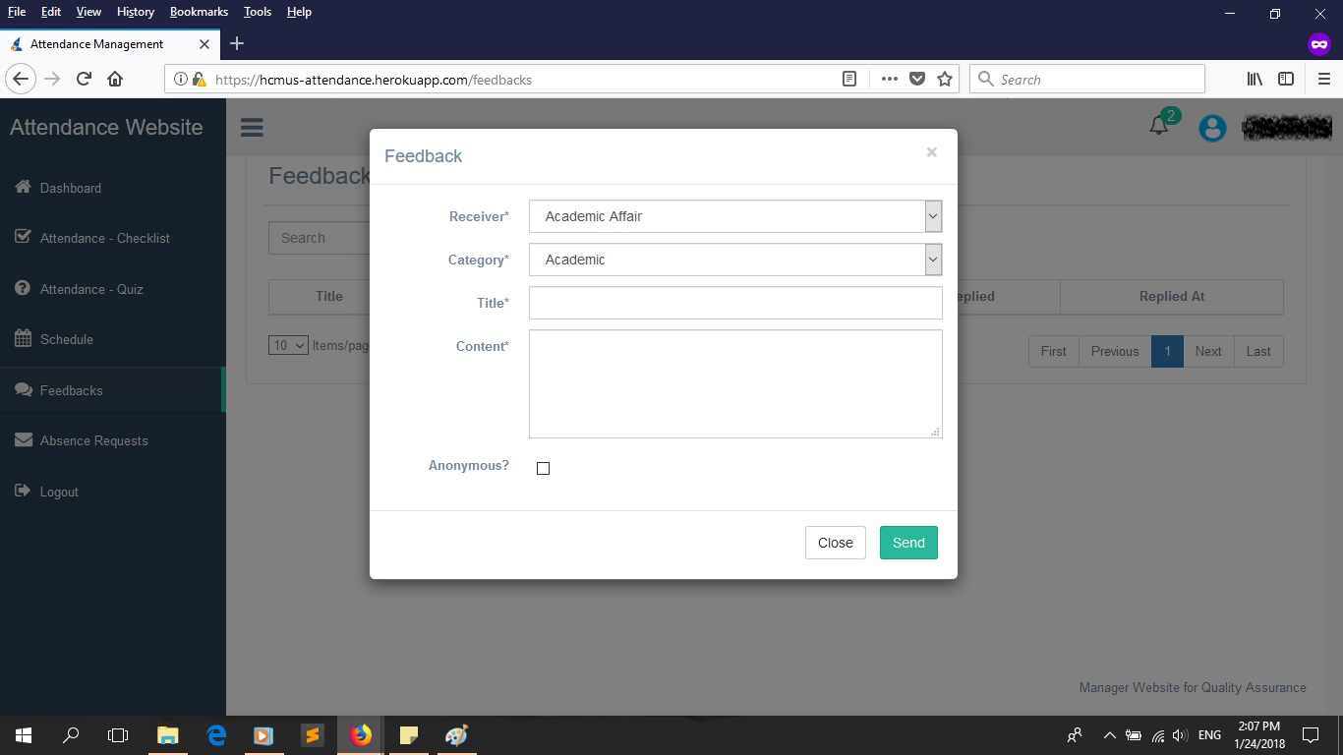

* Switch to ‘Absence Requests’ tab to view to see if your request has been accepted to or not.

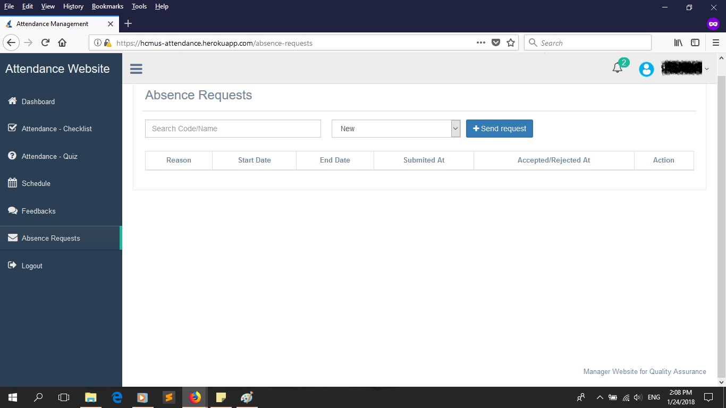

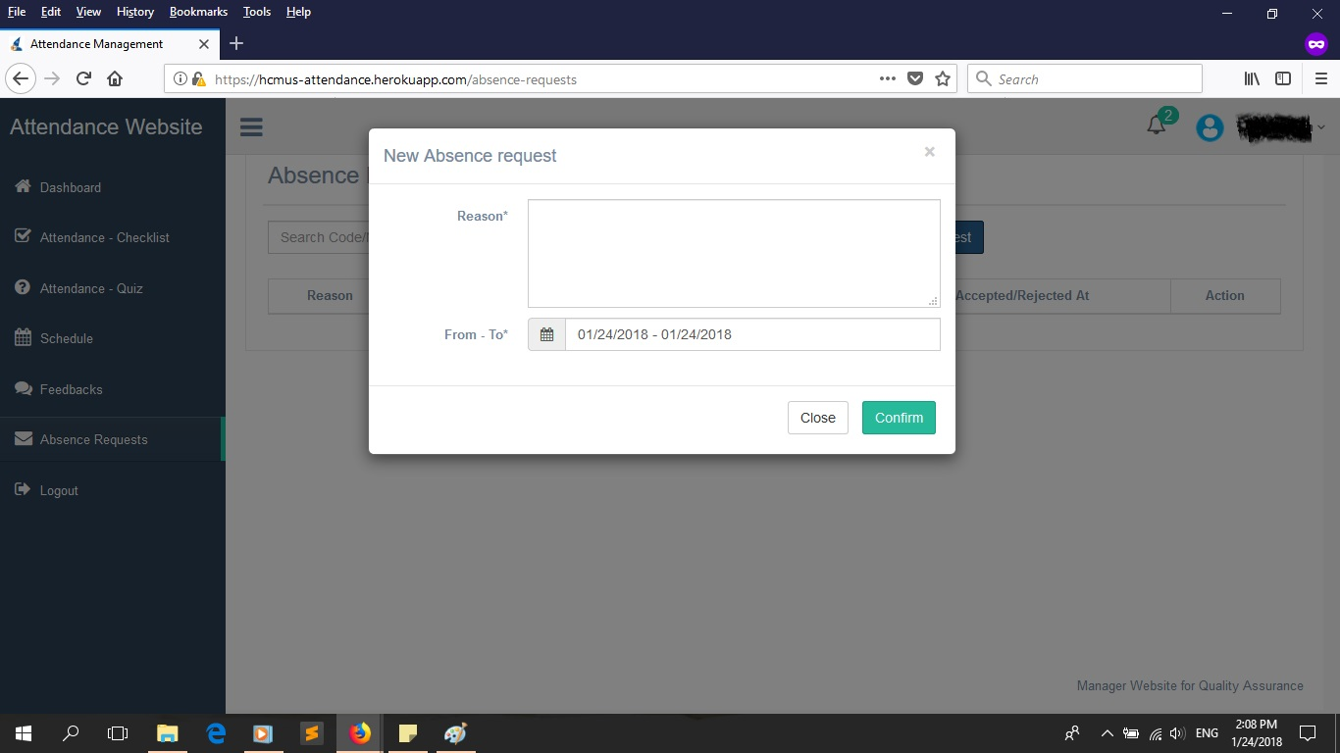

* There is also a special button (phone only), which is ‘QR CODE’. You can check in this way by scanning the QR code given by teacher.

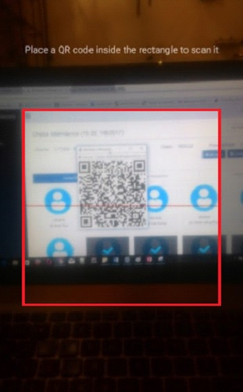

* Click on ‘Logout’ tab to check out.

1. *For Teacher:*

* The ‘Dashboard’ tab here is similar to that of Student, like image below. You can perform action similar to that of Student here like by clicking on respective buttons: Edit, Send Feedback, Change Password. In this tab, you can also view all currently opening courses.

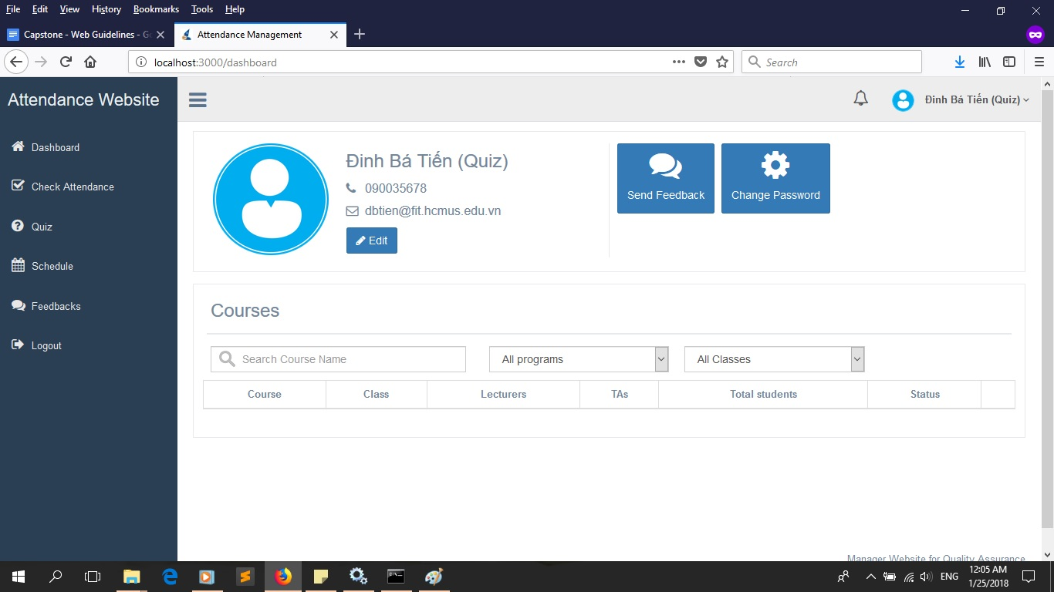

* Switch to ‘Quiz’ tab to create new quiz. Click ‘Add’ button to add a new quiz template (choose your class from drop down menu at the edge). In the new screen after click ‘Add’, fill in necessary information and click ‘+’ button if you want more questions. Finally, click ‘Save’ to save this quiz template.

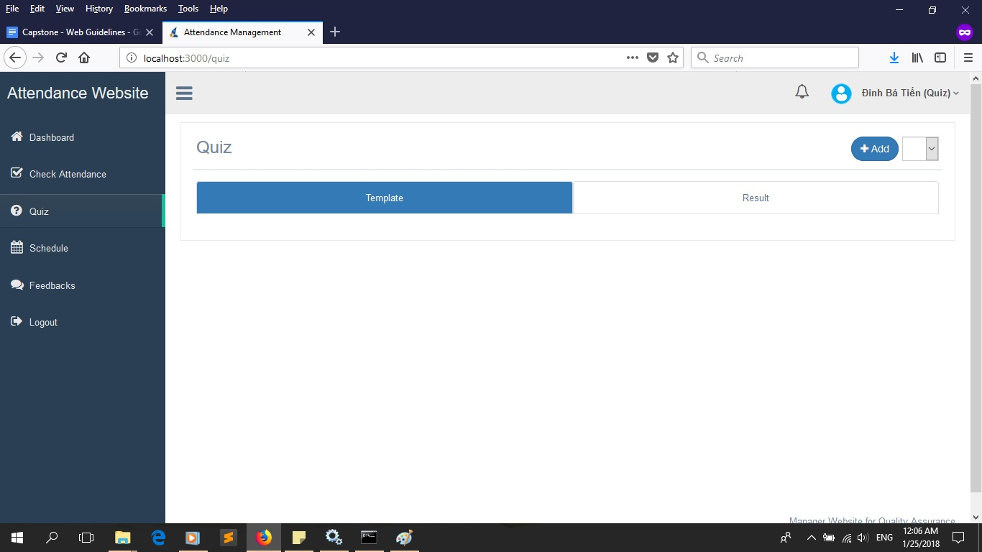

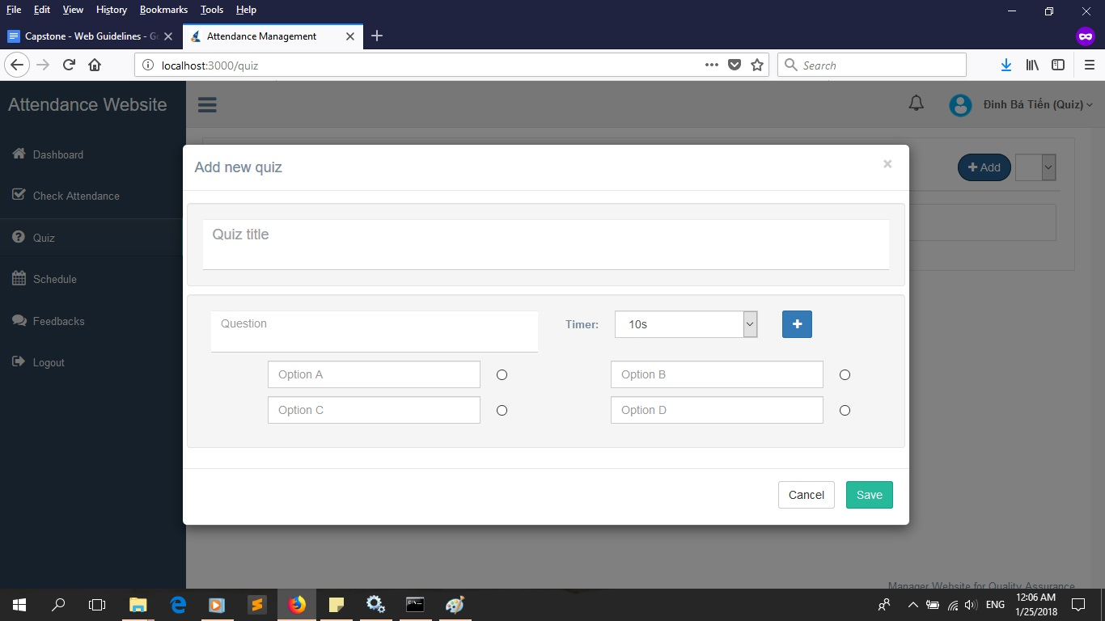

* Switch to ‘Check Attendance’ tab to check attendance of your students in courses. Click on the drop down menu near the edge to choose your class.
  + In here, you can view current student in class and click on their avatar to check them in ‘Current Week’ tab.

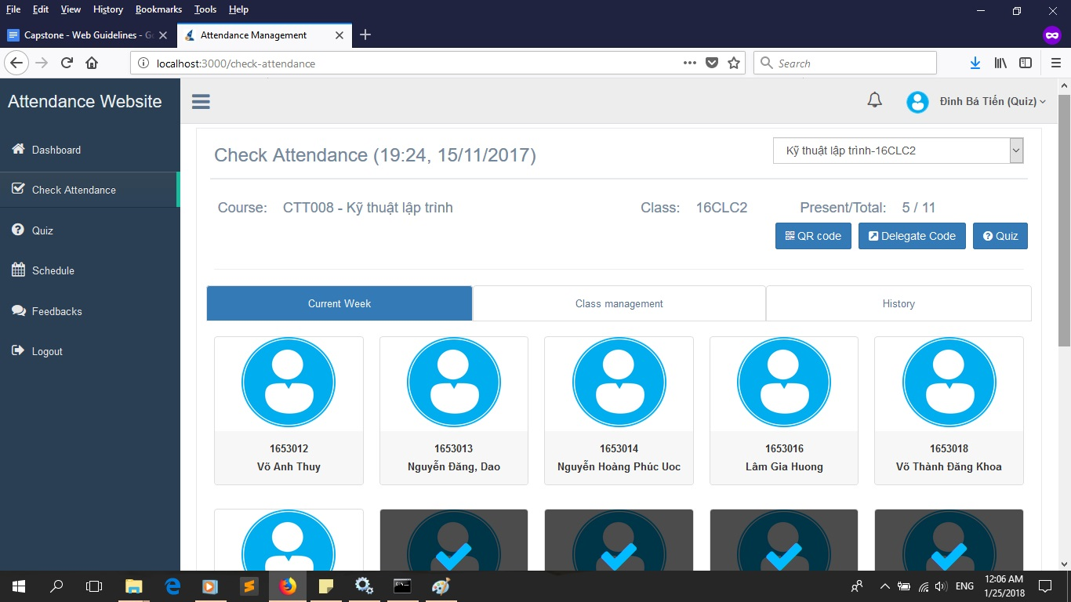

* + Click on ‘Class management’ tab to see the status of each of your student. In each of the avatar, there are 3 icon, which can be clicked to increase the number. They are:

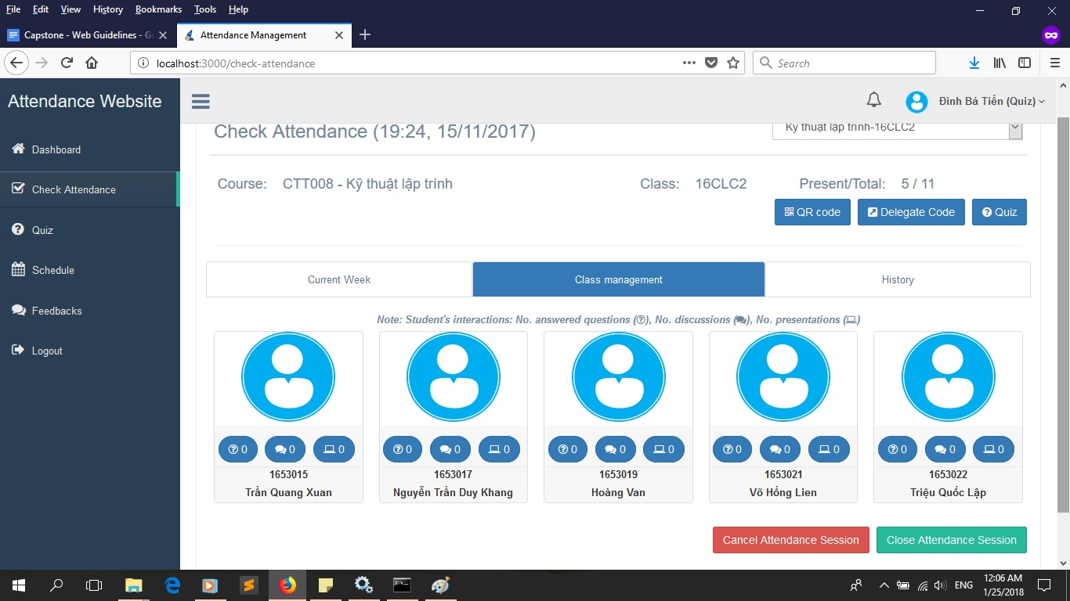

* + - Button  represents the number of answers a student did.
    - Button  represents the number of time a student discussed.
    - Button  represents the number of presentation a student did.
  + Click on ‘History’ tab to view your student’s absence status over the week.

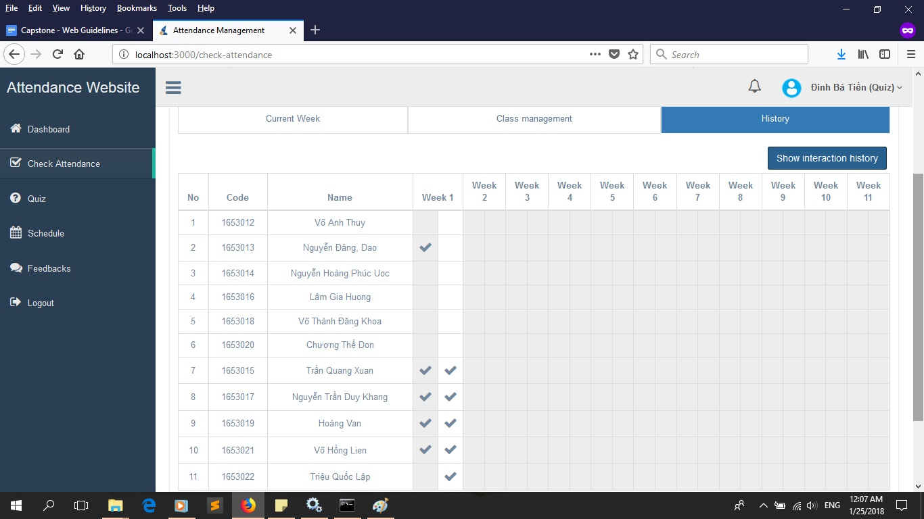

* + Click on ‘QR code’ button to create a random QR code for student to scan to check in.
  + Click on ‘Delegate code’ button if you can’t check in right now and want to give that right to a student in class. This will create a random code and the student who have that code can check attendance for you in this session.
  + Click on ‘Quiz’ button to check in by making a quiz test. In this screen, you can select ‘Quiz type’. For ‘Miscellaneous’, questions will be generated randomly, you can also choose how many questions, randomize their order and their answers.

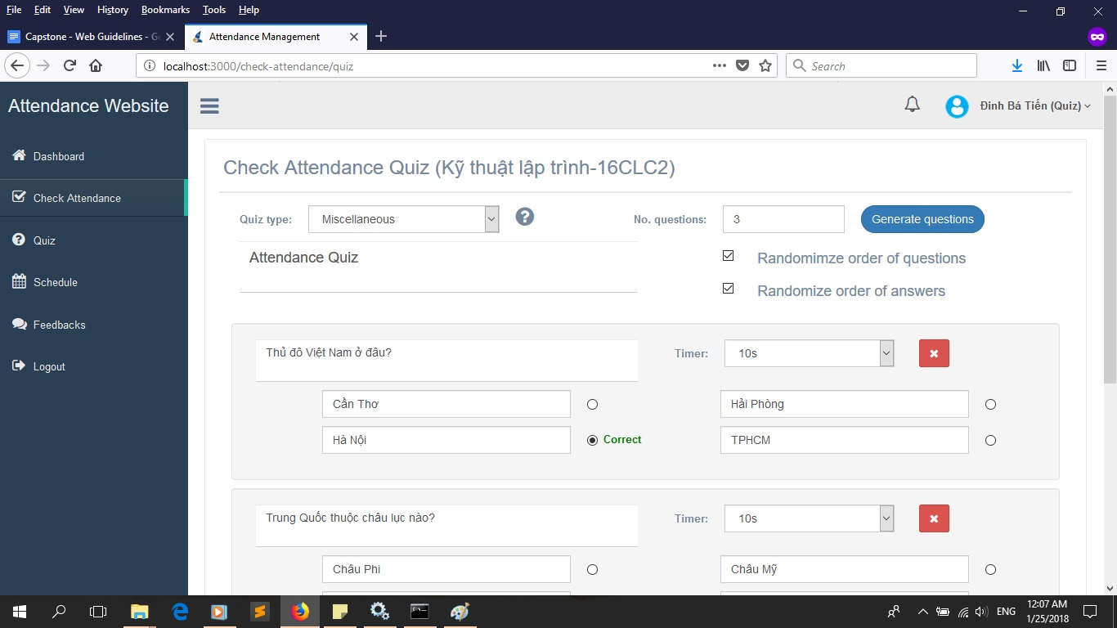

Otherwise, if you choose ‘Academic’, you will be given an option similar to the above: create new questions and randomize them. Or you can choose a template made in the ‘Quiz’ tab before. Either way, after finish choosing your quizzes, click on ‘Publish’ to let the student started doing your quizzes by giving a code to grant access.

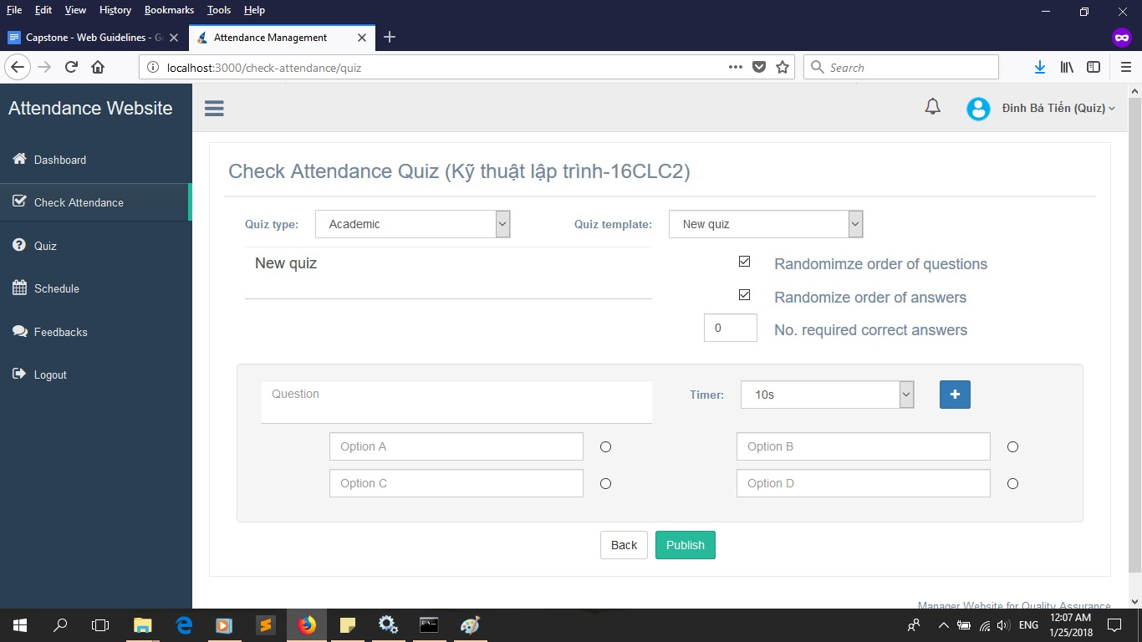

In the next screen, you can see the list of student joined in with a ‘Start’ button. Press it to start the test. Here, you can wait for the time to end or fast forward to next question or stop the test as you please.

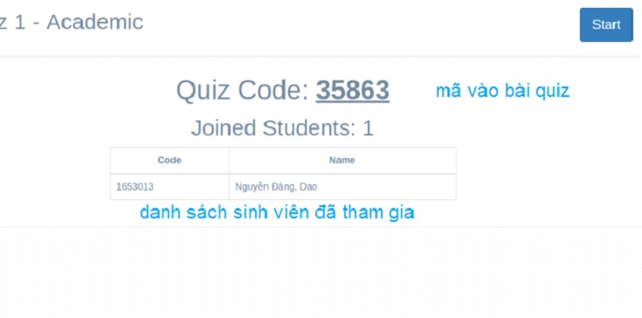

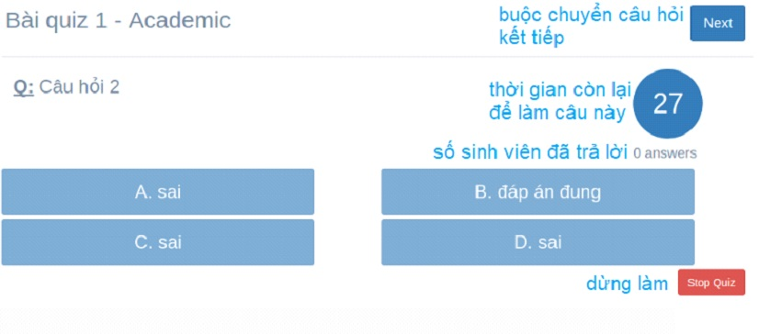

And finally, at the end, view the list of student that were checked in. Click ‘Close’ button to end.

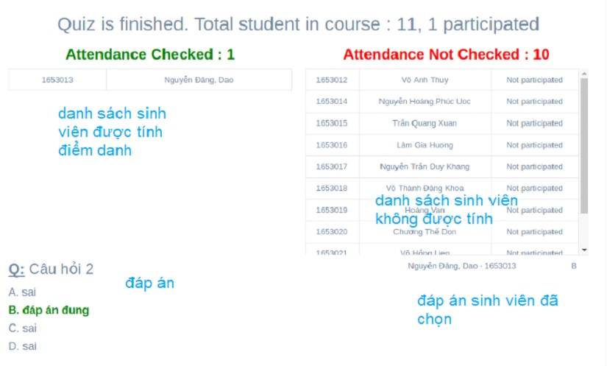

* + Click ‘Cancel Attendance Session’ to delete data of the current session.
  + Click ‘Close Attendance Session’ to close today’s session, no more checking.
* Switch to ‘Schedule’ tab to view the schedule of your courses over the weeks. Click on the date to view more details.

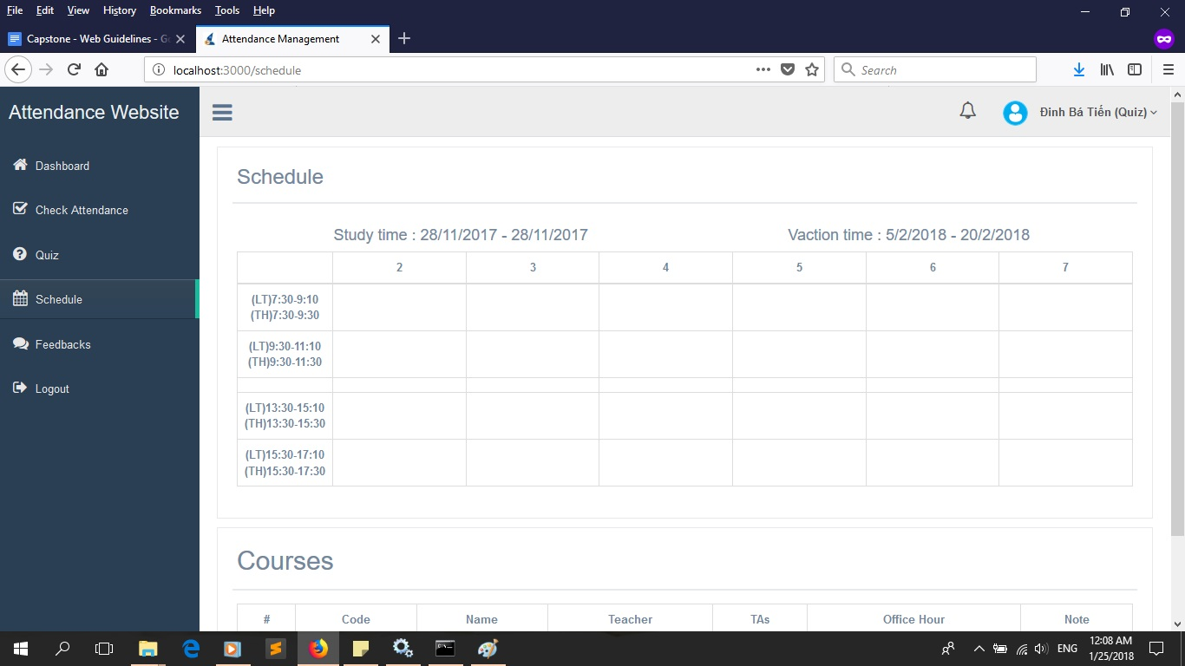

* Switch to ‘Feedbacks’ tab to view all your feedbacks and see if there were any reply yet.

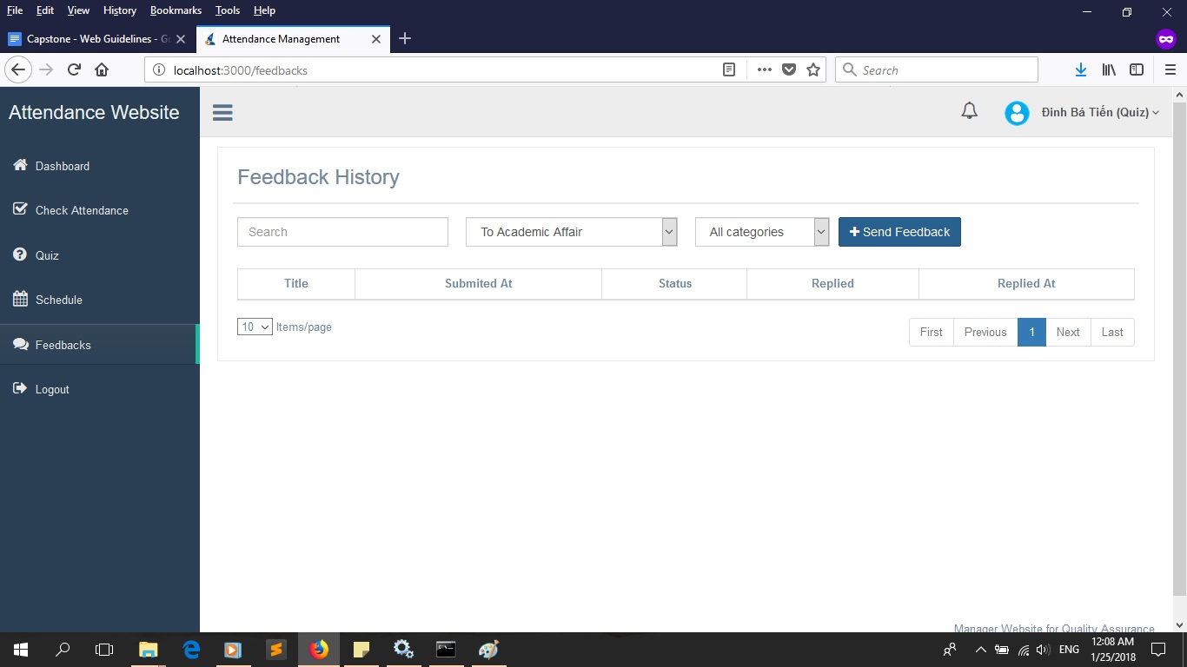

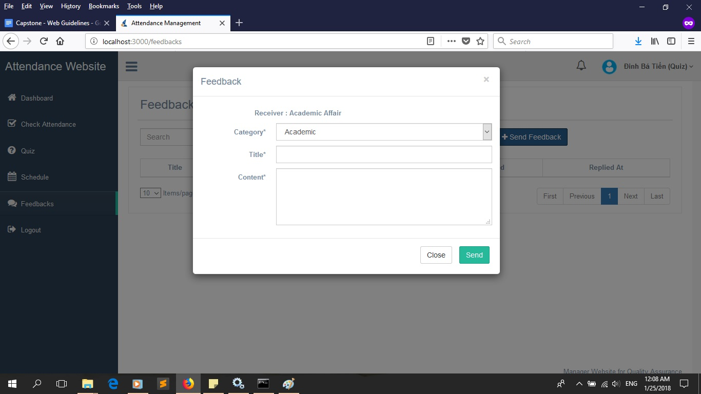

* Click on ‘Logout’ tab to check out.

1. *For Staffs:*

* The ‘Dashboard’ tab here is similar to that of Student, like image below. You can perform action similar to that of Student here like by clicking on respective buttons: Edit, Change Password.

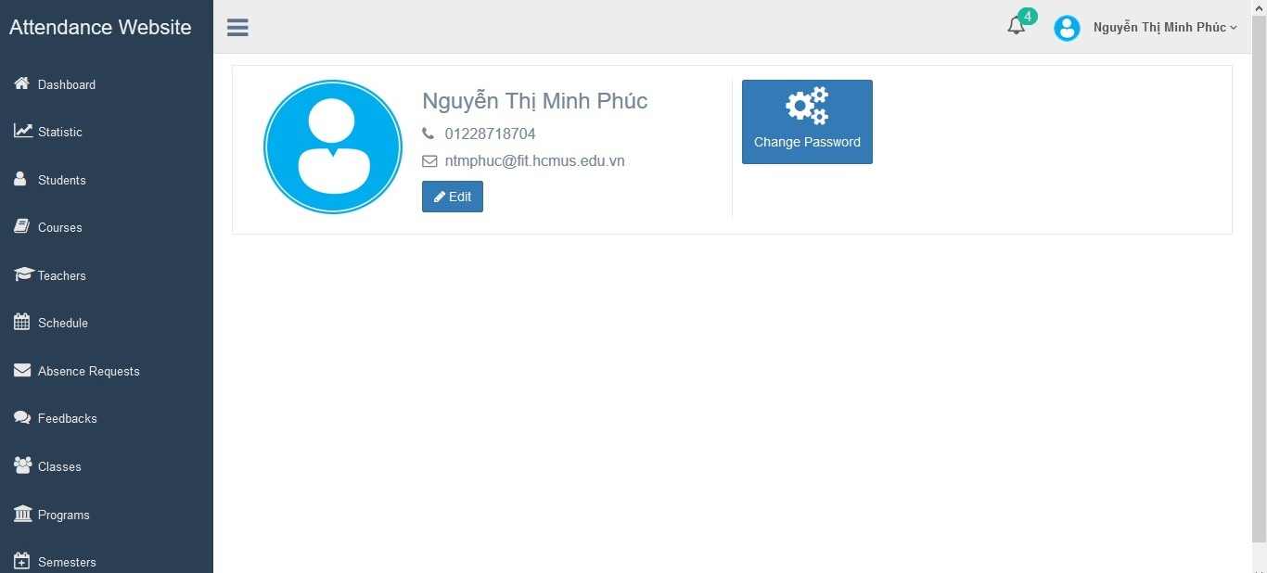

* Switch to ‘Statistic’ tab to be able to export the list of examinees, attendance summary, exceeded absences limit or attendance lists based on each button. When click on 1 button, you will be greeted by a screen in which you can choose what you want to export.

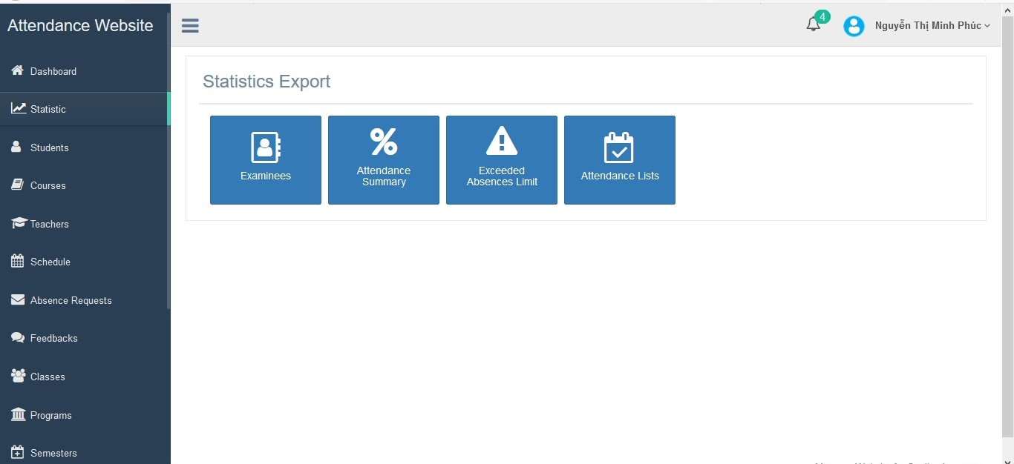

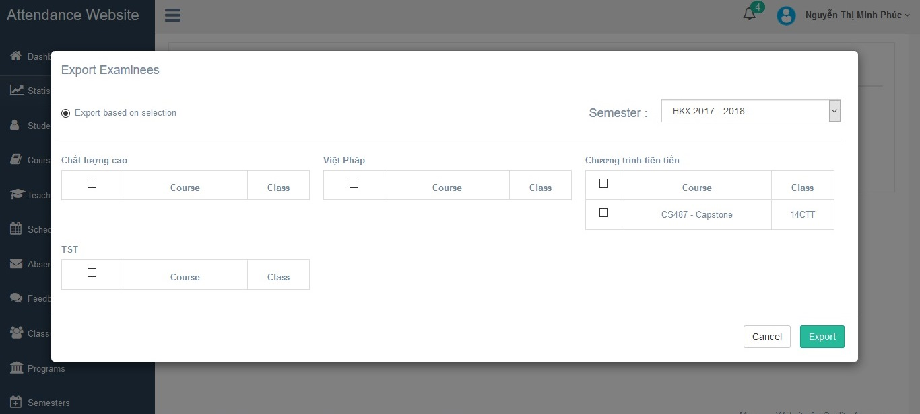

* Switch to ‘Program’ tab and click ‘Add’ button to add a new program. Please fill in all necessary information before clicking ‘Add’ button again.

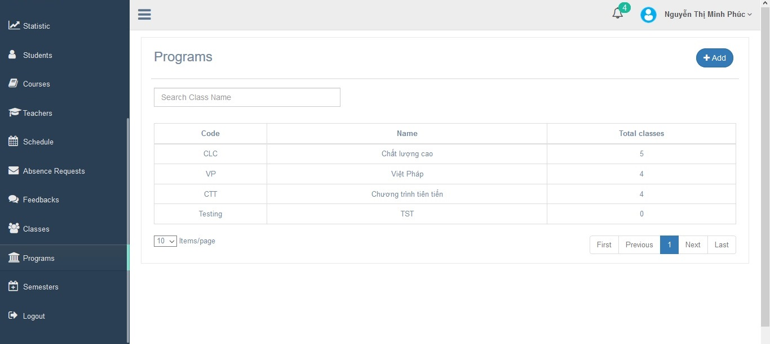

* Switch to ‘Semesters’ tab and click ‘Add’ button to add a new semester. Fill in the name, study time and vacation time before clicking ‘Add’ button again.

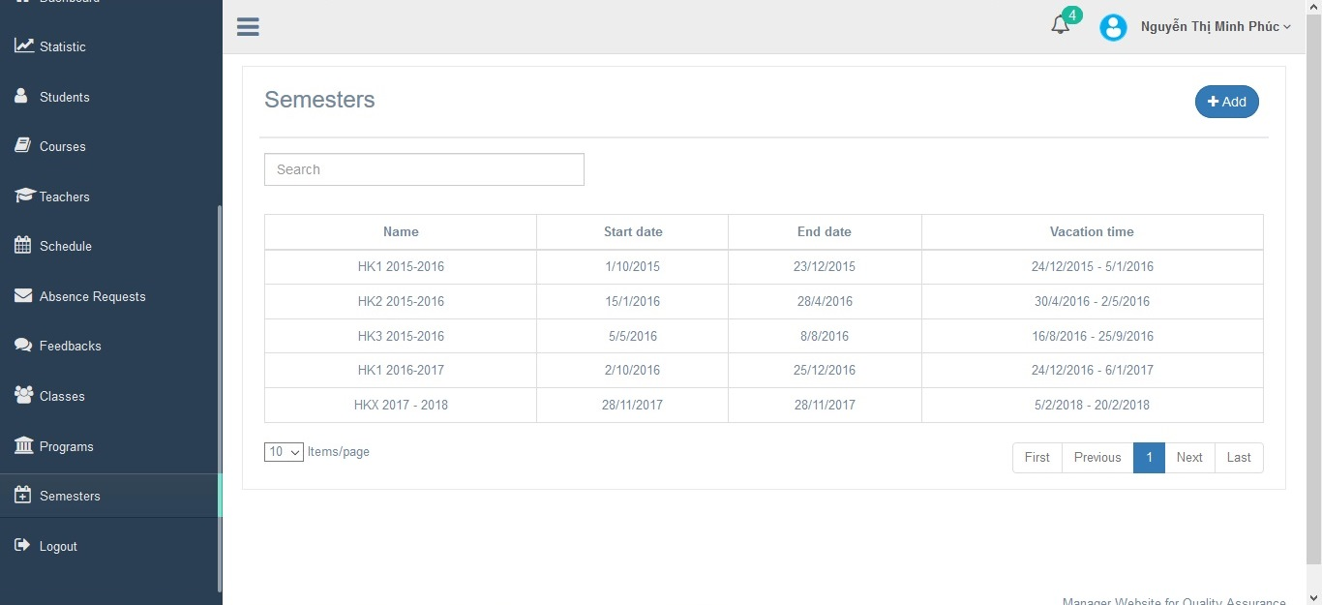

* Switch to ‘Classes’ tab and click ‘Import’ button to add a new class by uploading an excel file for this. Click ‘Import’ button again for confirmation.

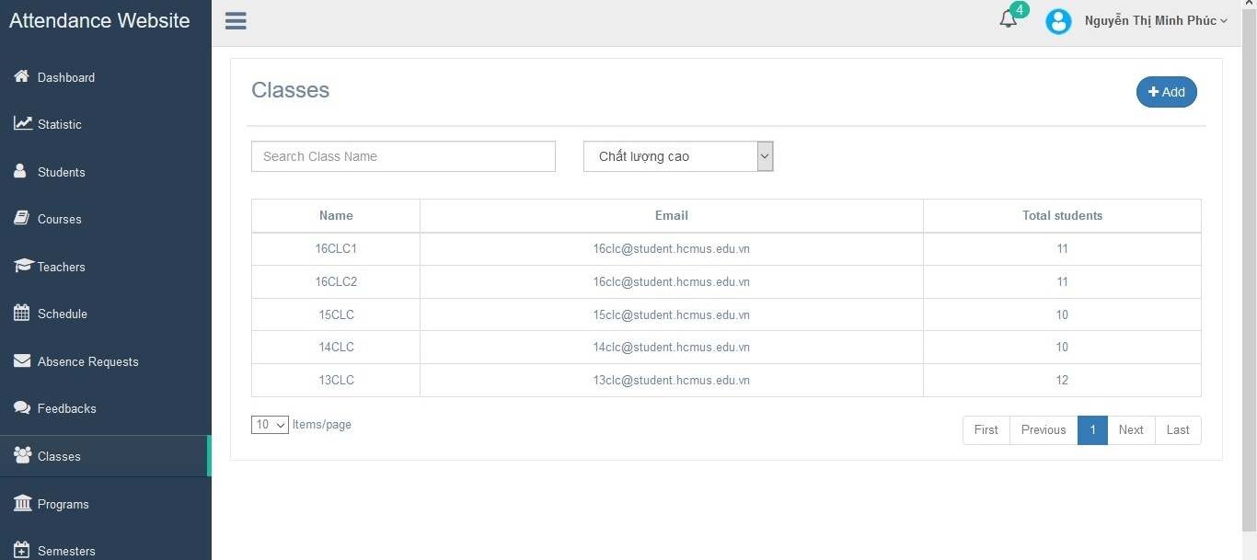

* Switch to ‘Courses’ tab and click ‘Add’ button to add a new course to the system. Please fill in all necessary information and choose your schedule as well as the list of student.

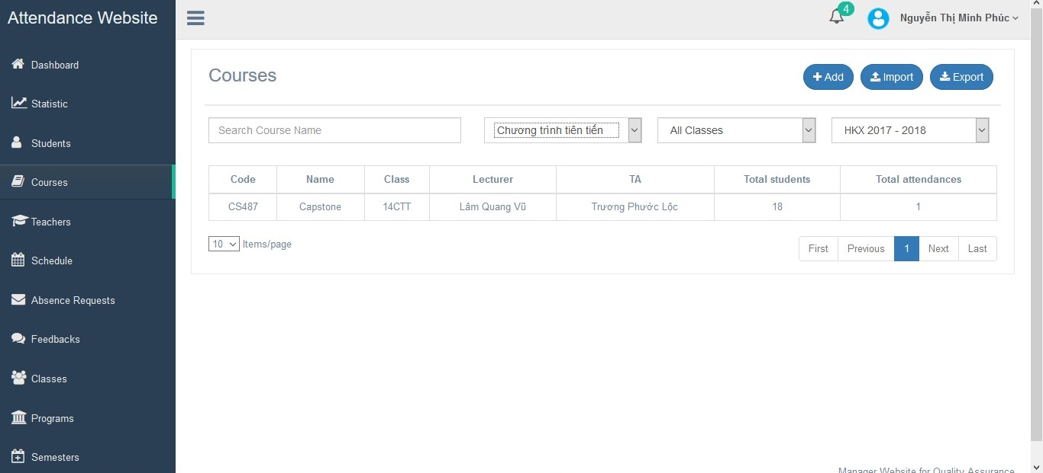

In this tab, you can also add your attendance information to the class you already have by clicking on that class and click ‘Import’ button to upload an excel file for this. Click ‘Import’ button again for confirmation. You can also export information of a course by clicking ‘Export’ button.

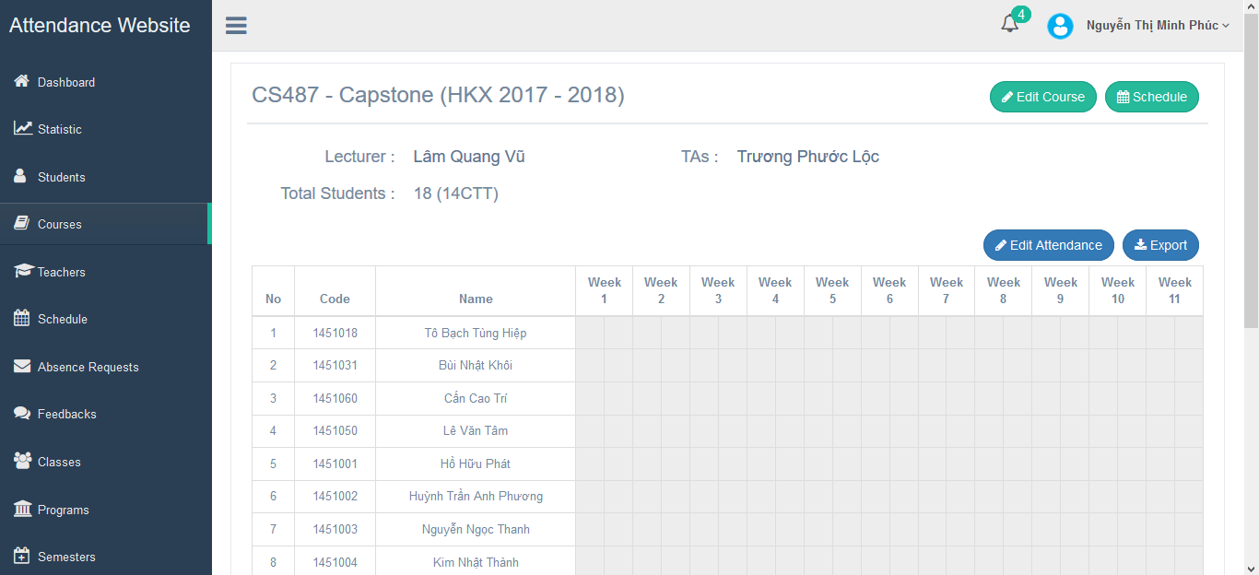

Click ‘Edit Attendance’ button to edit the student’s attendance information. In here, you can also add a new student to this course or erase a student. Before you finish changing, you must input the reason for changing. Finally, click ‘Save’ to save all the changes.

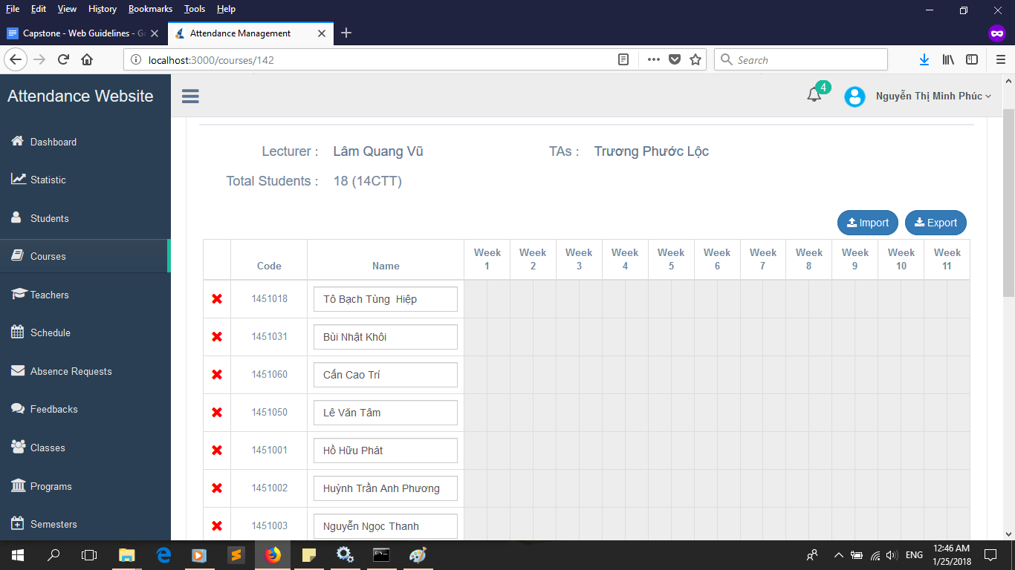

* Switch to ‘Feedbacks’ to view all currently presented feedbacks. Click on each of them to view more detail and reply.

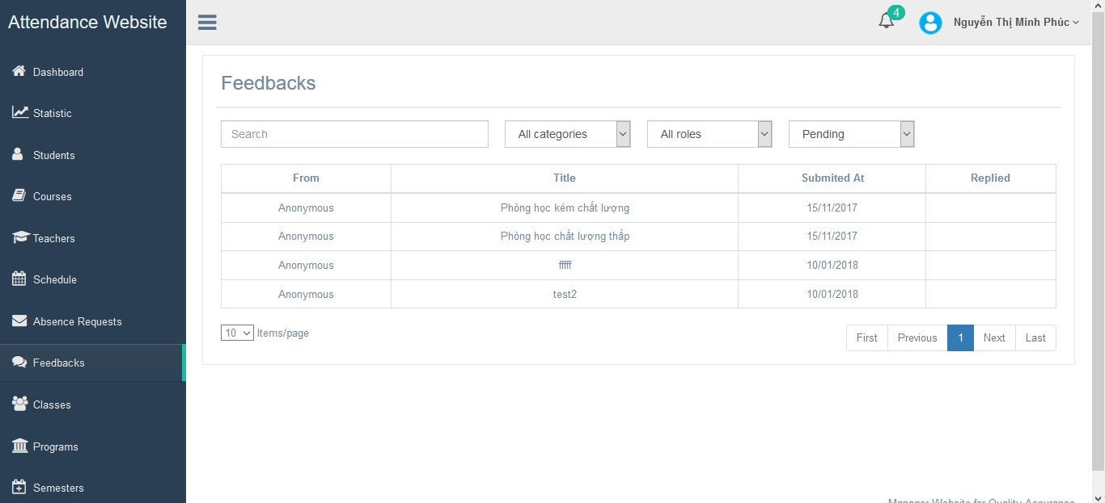

* Switch to ‘Absence Request’ to view all currently presented requests. Click ‘Accept’ button to accept that request or ‘Reject button’ otherwise.

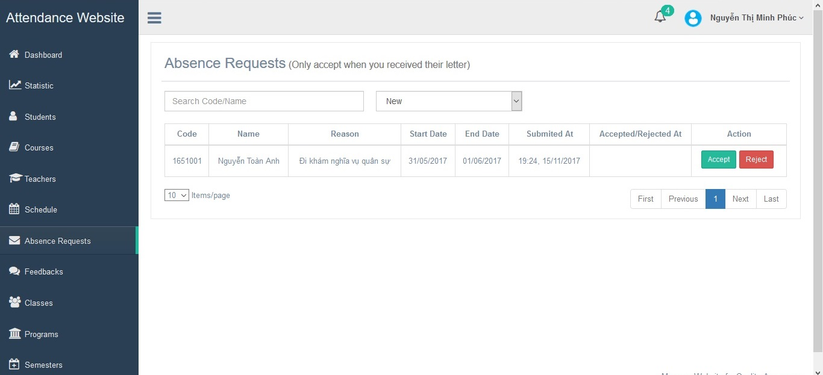

* Switch to ‘Students’ tab to view the list of all students in all programs and classes, as well as their status (Active or Drop). You can also import a new list with an excel file with ‘Import’ button, add a student hand-by-hand with ‘Add’ button or export the list of students you want with ‘Export’ button.

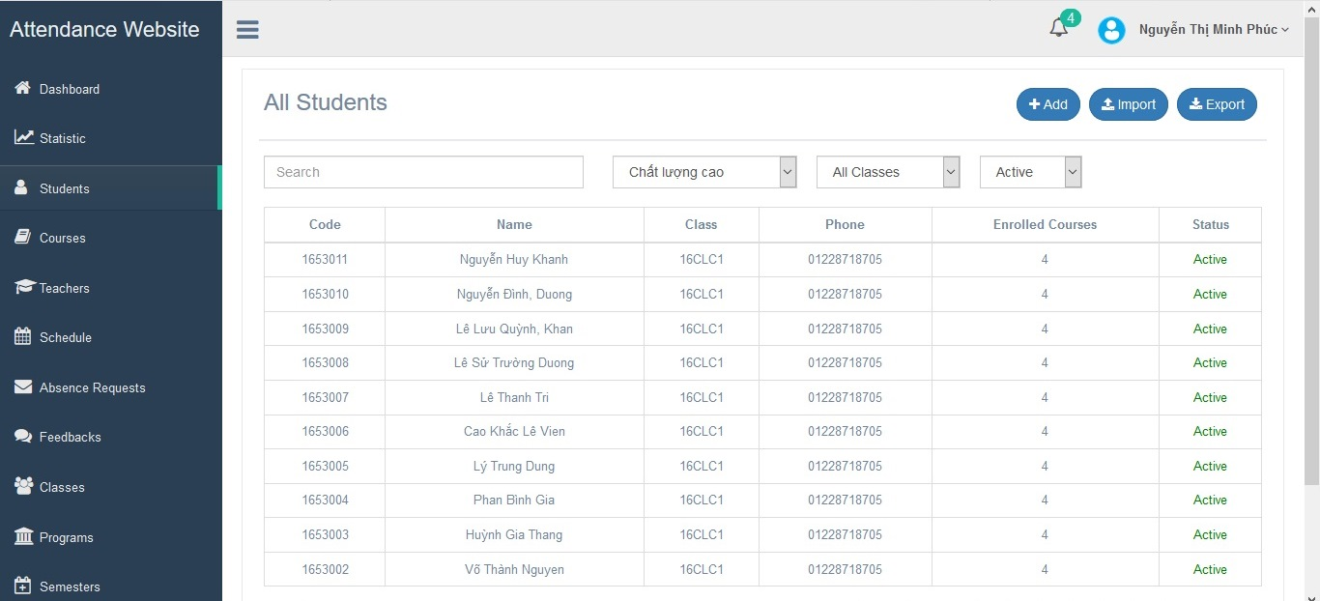

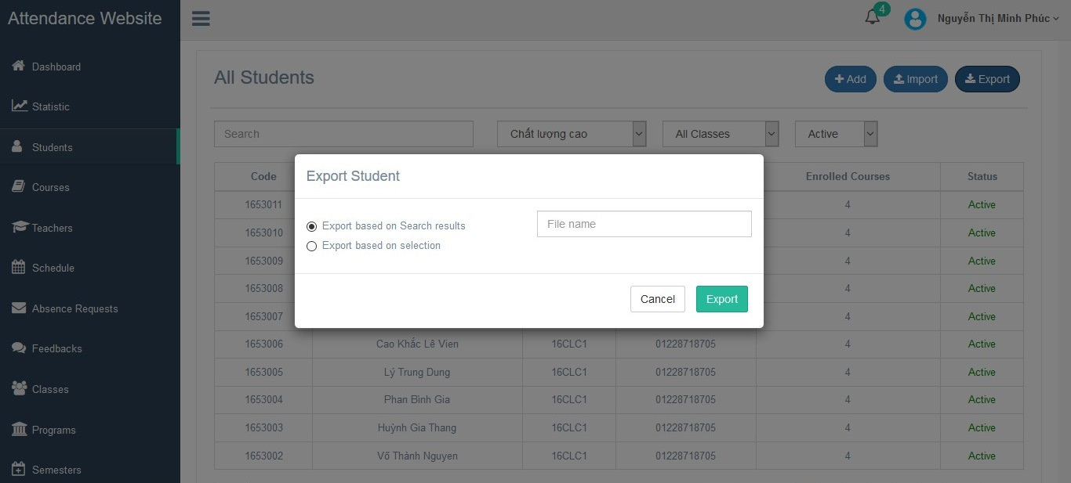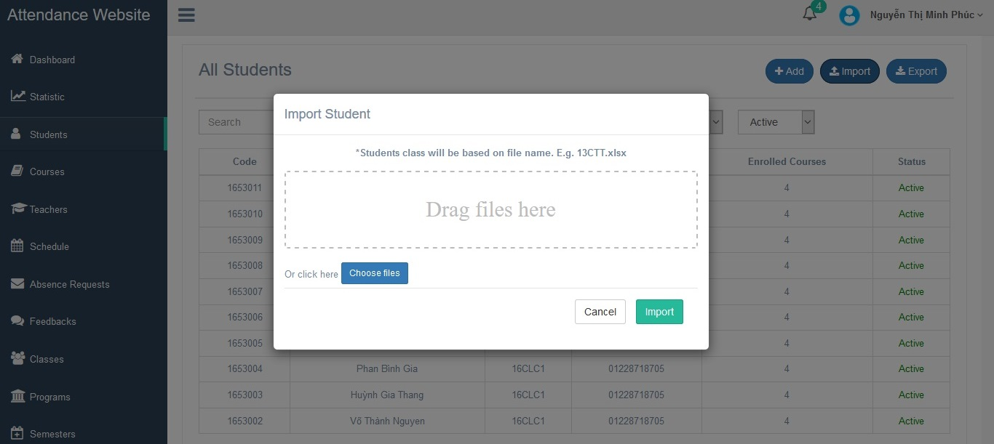

You can also click on each student’s name to edit their personal information or make an exception for that student in a class by clicking on ‘Normal’ button (in ‘Attendance Status’ column) of that class, then click ‘Confirm’ button.

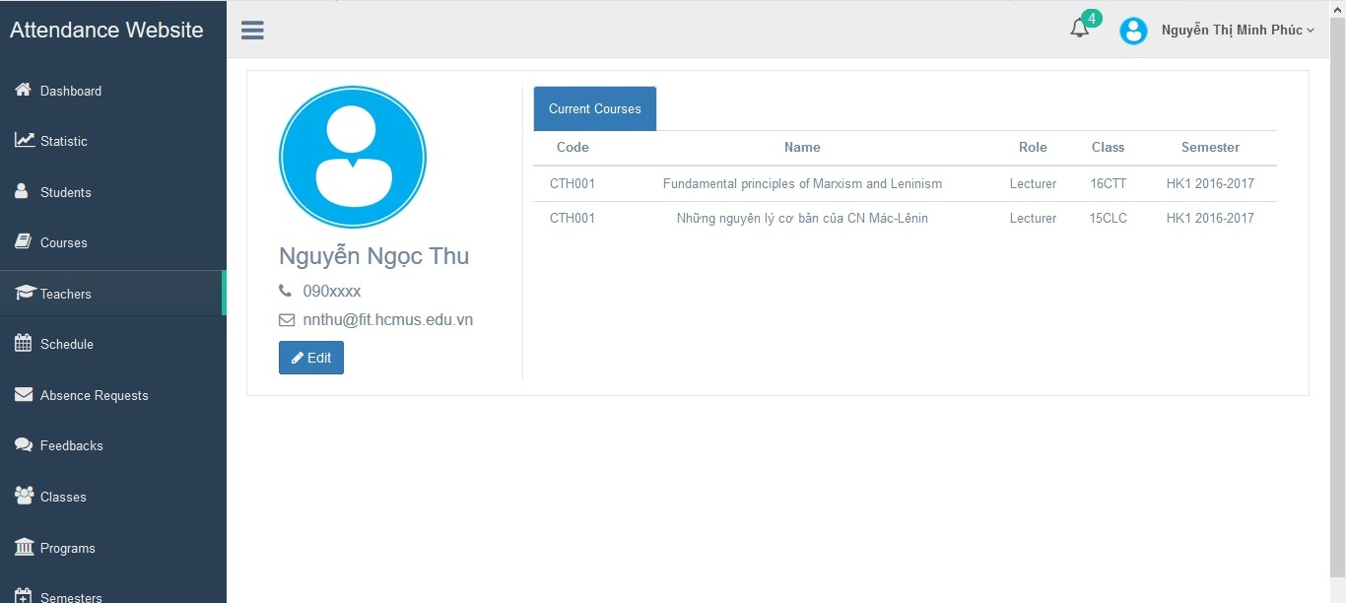

* Switch to ‘Teachers’ tab to view the list of all teachers and their information. You can also import a new list with an excel file with ‘Import’ button, add a student hand-by-hand with ‘Add’ button or export the list of teachers you want with ‘Export’ button.

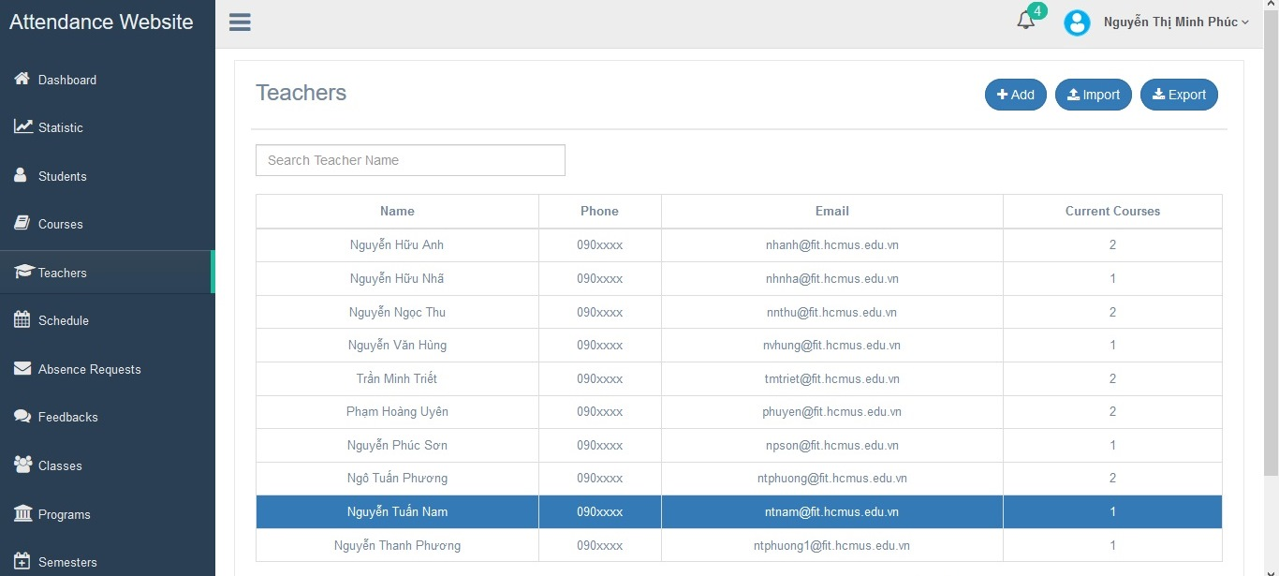

You can also click on each teacher’s name to edit their personal information.



1. *For Admin:*

* This account is special as it is only used to add more Staffs to the system. Login to this, you will see a similar dashboard with others except for ‘Staff List’ tab to let you add or remove staffs.

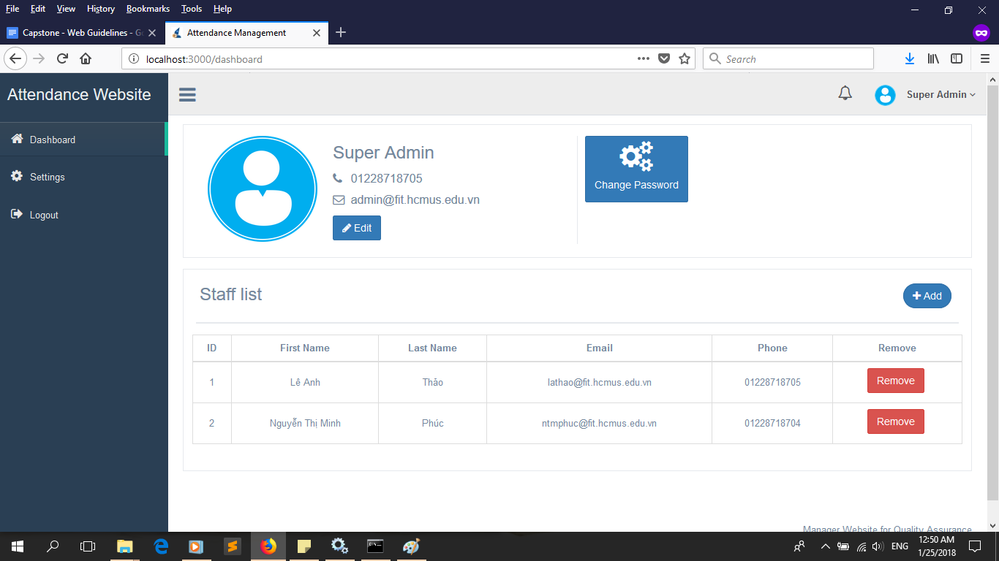

* Switch to ‘Setting Tab’ and you will see some information, this is the place where the feedbacks and replies will be sent to before direct back to the other parties. In here, you can change your host (Office365/Gmail) and your email, password and signature. After finish changing, click ‘Save’ to save the new information.

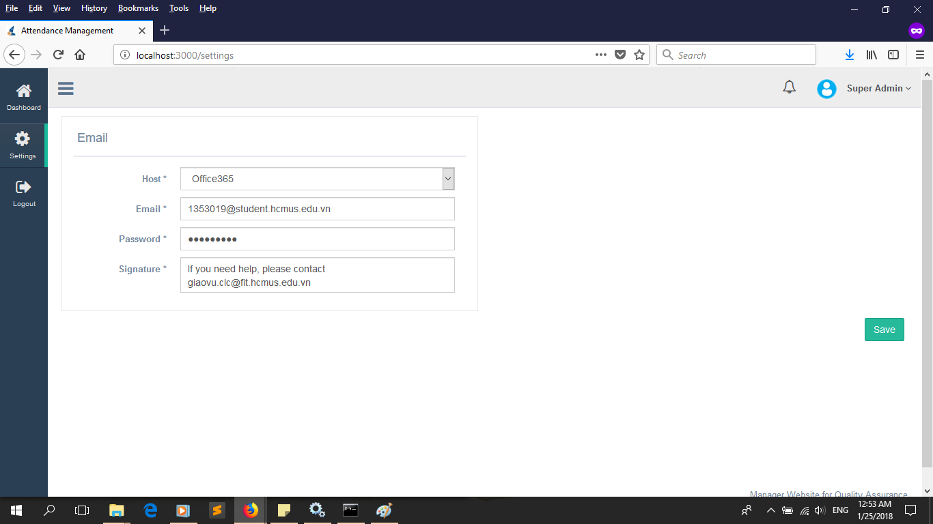

* Switch to ‘Logout’ tab to check out of your account.